PostgreSQL Regular Exam
Exam problems for the PostgreSQL course @ Software University.
Submit your solutions in the SoftUni Judge Contest.

Soccer Talent

You've been selected to help soccer coaches pick the best players for their teams. Using your database skills, you're creating Soccer Talent a custom database with expert scout data. Once done, you can easily answer coaches' queries and streamline player selection. Mastering the database structure comes first, then filling it with soccer talent data. Welcome to a world where your database skills shape the future stars of the beautiful game.

Section 1. Data Definition Language (DDL) - (30 pts)
The E/R Diagram for Soccer Talent has been supplied to you. This diagram illustrates the connections among different entities within Soccer Talent, offering a visual depiction of the database structure.
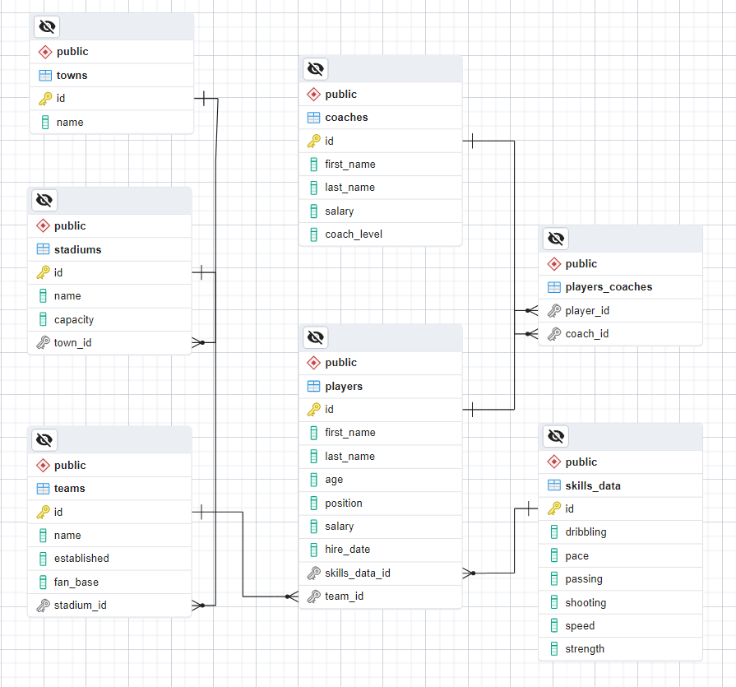
Create a PostgreSQL database named "soccer_talent_db" that comprises seven tables:
- "towns" - contains information about the players' towns;
- "stadiums" - holds data about the stadiums;
- "teams" - contains information about the teams;
- "coaches" - stores details about the coaches. A coach can train multiple players;
- "skills_data" - holds information about the current player's skills;
- "players" - contains details about the players;
- "players_coaches" - serves as a many-to-many mapping table between players and coaches;
NOTE: Please ensure that you use the exact data types specified in the model tables when working with dates. For instance, if a column is of type "DATE," make sure to use the "DATE" type. Similarly, if a column is of type "TIMESTAMP" use the "TIMESTAMP" data type. If you use an incorrect type, the Judge system will not accept your submission as correct.
Your first task is to set up the database tables following the provided models. Follow the specifications closely, maintaining the same column order as shown below.

towns
Column Name | Data Type | Constraints
id | Integer from 0 to 2,147,483,647 | Primary Key, Unique table identification, Auto-increment
name | String up to 45 symbols | NULL is not allowed

stadiums
Column Name | Data Type | Constraints
id | Integer from 0 to 2,147,483,647 | Primary Key, Unique table identification, Auto-increment
name | String up to 45 symbols | NULL is not allowed
capacity | Integer from 0 to 2,147,483,647 | The capacity is a positive number greater than 0  NULL is not allowed
town_id | Integer from 0 to 2,147,483,647 | Relationship with table towns, Cascade Operations, NULL is not allowed

teams
Column Name | Data Type | Constraints
id | Integer from 0 to 2,147,483,647 | Primary Key, Unique table identification, Auto-increment
name | String up to 45 symbols | NULL is not allowed
established | DATE | NULL is not allowed
fan_base | Integer from 0 to 2,147,483,647 | The DEFAULT value is 0, the column must always have a value greater than or equal to zero  NULL is not allowed
stadium_id | Integer from 0 to 2,147,483,647 | Relationship with table stadiums, Cascade Operations, NULL is not allowed

coaches
Column Name | Data Type | Constraints
id | Integer from 0 to 2,147,483,647 | Primary Key, Unique table identification, Auto-increment
first_name | String up to 10 symbols | NULL is not allowed
last_name | String up to 20 symbols | NULL is not allowed
salary | Numeric number with a precision of 10 digits, including 2 digits after the decimal point | The DEFAULT value is 0, the column must always have a value greater than or equal to zero  NULL is not allowed
coach_level | Integer from 0 to 2,147,483,647 | The DEFAULT value is 0, the column must always have a value greater than or equal to zero  NULL is not allowed

skills_data
Column Name | Data Type | Constraints
id | Integer from 0 to 2,147,483,647 | Primary Key, Unique table identification, Auto-increment
dribbling | Integer from 0 to 2,147,483,647 | The DEFAULT value is 0, the column must always have a value greater than or equal to zero  NULL is permitted
pace | Integer from 0 to 2,147,483,647 | The DEFAULT value is 0, the column must always have a value greater than or equal to zero  NULL is permitted
passing | Integer from 0 to 2,147,483,647 | The DEFAULT value is 0, the column must always have a value greater than or equal to zero  NULL is permitted
shooting | Integer from 0 to 2,147,483,647 | The DEFAULT value is 0, the column must always have a value greater than or equal to zero  NULL is permitted
speed | Integer from 0 to 2,147,483,647 | The DEFAULT value is 0, the column must always have a value greater than or equal to zero  NULL is permitted
strength | Integer from 0 to 2,147,483,647 | The DEFAULT value is 0, the column must always have a value greater than or equal to zero  NULL is permitted

players
Column Name | Data Type | Constraints
id | Integer from 0 to 2,147,483,647 | Primary Key, Unique table identification, Auto-increment
first_name | String up to 10 symbols | NULL is not allowed
last_name | String up to 20 symbols | NULL is not allowed
age | Integer from 0 to 2,147,483,647 | The DEFAULT value is 0, the column must always have a value greater than or equal to zero  NULL is not allowed
position | String limited to 1 character | NULL is not allowed
salary | Numeric number with a precision of 10 digits, including 2 digits after the decimal point | The DEFAULT value is 0, the column must always have a value greater than or equal to zero  NULL is not allowed
hire_date | TIMESTAMP indicates when the player's contract starts | NULL is permitted
skills_data_id | Integer from 0 to 2,147,483,647 | Relationship with table skills_data, Cascade Operations, NULL is not allowed
team_id | Integer from 0 to 2,147,483,647 | Relationship with table teams, Cascade Operations, NULL is permitted

players_coaches
Column Name | Data Type | Constraints
player_id | Integer from 0 to 2,147,483,647 | Relationship with table players, Cascade Operations, NULL is permitted
coach_id | Integer from 0 to 2,147,483,647 | Relationship with table coaches, Cascade Operations, NULL is permitted

Database Design
Submit only your CREATE statements for all tables to the Judge.

Section 2. Data Manipulation Language (DML) - (10 pts)
Before beginning, it is necessary to import "dataset.sql". The data should be inserted successfully if the structure has been properly created.
This section requires performing various data manipulations:

Insert
Players hired before '2013-12-13 07:18:46' are eligible to apply for coaching positions. Your task is to update the "coaches" table by extracting information from the "players" table. Insert data into the "coaches" table with the following specifications:
- set the "first_name" to the player's first name.
- set the "last_name" to the player's last name.
- set the "salary" to double the player's salary.
- set the "coach_level" to the character count of the player's first name.

Example
id | first_name | last_name | salary | coach_level
1 | Anollie | Phelip | 578112.19 | 4
2 | Aster | Krolak | 876807.09 | 1
3 | Aesra | Simoneton | 336677.23 | 4
… | … | … | … | …
9 | Rudie | Gorgl | 460354.93 | 2
10 | Lewes | Dymocke | 898257.96 | 7
11 | Harlie | Sandells | 1580855.78 | 6
12 | Thor | Serrels | 911203.34 | 4
… | … | … | … | …
43 | Curtis | Lawrenceson | 74142.90 | 6
44 | Kate | Taylder | 991817.08 | 4
45 | Jorrie | Lumsden | 1016070.88 | 6

Update
For the upcoming task, update the salaries of coaches whose "first_name" starts with 'C' and who train one or more players. Increase the "salary" by multiplying their current "salary" by their "coach_level".

Example
Before update
id | first_name | last_name | salary | coach_level
1 | Anollie | Phelip | 578112.19 | 4
… | … | … | … | …
7 | Mickey | Dabernott | 680019.08 | 7
8 | Chilton | Cookley | 56839.58 | 4
9 | Rudie | Gorgl | 460354.93 | 2
… | … | … | … | …
15 | Jorrie | Lumsden | 1016070.88 | 6

After update
id | first_name | last_name | salary | coach_level
1 | Anollie | Phelip | 578112.19 | 4
… | … | … | … | …
7 | Mickey | Dabernott | 680019.08 | 7
8 | Chilton | Cookley | 227358.32 | 4
9 | Rudie | Gorgl | 460354.93 | 2
… | … | … | … | …
15 | Jorrie | Lumsden | 1016070.88 | 6

Delete
As you may recall, at the beginning of our project, we promoted several football players to coaching roles. To ensure the accurate update of our database, your assignment is to remove all instances of these promoted players from the "players" table. More specifically, eliminate players hired before '2013-12-13 07:18:46'. Additionally, delete all associated records for these players from the "players_coaches" table.
To successfully accomplish the specified task, make sure to submit all SQL queries to the Judge

Example
Before delete
id | first_name | last_name | age | position | salary | hire_date | skills_data_id | team_id
1 | Alden | Wrettum | 21 | A | 32283.83 | [null] | 87 | [null]
2 | Dayna | Halesworth | 23 | M | 897853.69 | 2020-01-15 07:26:33 | 88 | 77
… | … | … | … | … | … | … | … | …
11 | Curry | Brando | 17 | M | 511422.90 | 2019-08-16 16:02:01 | 34 | 36
12 | Thor | Serrels | 24 | D | 455601.67 | 2013-03-19 15:23:23 | 47 | 36
13 | Berkie | Maryin | 45 | A | 698230.79 | 2016-12-27 13:45:05 | 65 | 77
… | … | … | … | … | … | … | … | …
16 | Eldin | Gravet | 35 | D | 821422.57 | 2019-03-23 11:24:11 | 69 | 53
17 | Glory | Crosetti | 28 | A | 394462.27 | 2010-08-05 19:01:14 | 13 | 1
18 | Doretta | Rignold | 42 | M | 665969.43 | 2015-09-18 11:43:44 | 40 | 66
… | … | … | … | … | … | … | … | …
19 | Gwendolen | Semple | 17 | D | 407582.09 | [null] | 94 | [null]
20 | Launce | Perchard | 44 | A | 899242.30 | 2013-09-13 14:16:39 | 70 | 13
21 | Vasili | Grigorescu | 45 | M | 46428.66 | 2013-12-13 07:18:46 | 91 | 76
… | … | … | … | … | … | … | … | …
99 | Miranda | Frichley | 45 | A | 307130.04 | 2019-06-20 16:31:41 | 53 | 22
100 | Jorrie | Lumsden | 50 | M | 508035.44 | 2010-09-19 11:52:56 | 4 | 54

player_id | coach_id
1 | 1
54 | 2
17 | 5
33 | 4
24 | 8
66 | 10
90 | 5
4 | 6
39 | 10
71 | 8
After delete
id | first_name | last_name | age | position | salary | hire_date | skills_data_id | team_id
1 | Alden | Wrettum | 21 | A | 32283.83 | [null] | 87 | [null]
2 | Dayna | Halesworth | 23 | M | 897853.69 | 2020-01-15 07:26:33 | 88 | 77
… | … | … | … | … | … | … | … | …
11 | Curry | Brando | 17 | M | 511422.90 | 2019-08-16 16:02:01 | 34 | 36
13 | Berkie | Maryin | 45 | A | 698230.79 | 2016-12-27 13:45:05 | 65 | 77
… | … | … | … | … | … | … | … | …
16 | Eldin | Gravet | 35 | D | 821422.57 | 2019-03-23 11:24:11 | 69 | 53
18 | Doretta | Rignold | 42 | M | 665969.43 | 2015-09-18 11:43:44 | 40 | 66
… | … | … | … | … | … | … | … | …
19 | Gwendolen | Semple | 17 | D | 407582.09 | [null] | 94 | [null]
21 | Vasili | Grigorescu | 45 | M | 46428.66 | 2013-12-13 07:18:46 | 91 | 76
… | … | … | … | … | … | … | … | …
99 | Miranda | Frichley | 45 | A | 307130.04 | 2019-06-20 16:31:41 | 53 | 22

player_id | coach_id
1 | 1
33 | 4
24 | 8
90 | 5
4 | 6
39 | 10

Section 3. Querying - (40 pts)
Now we will perform some data extraction tasks. Please note that the example results provided in this section are based on a fresh database. It is highly recommended to clear the database that was manipulated in the previous problems from the DML section and insert the given dataset again to ensure consistency with the examples in this section.

Players
Extract information about all the "players" with their "full_name" (concatenation of "first_name" and "last_name"), "age", and "hire_date". Select only the players whose "first_name" starts with 'M%'. Sort the list by "age" in descending order. If there is more than one player with the same age, the results should be further sorted by their "full_name" in ascending order.

Example
full_name | age | hire_date
Meredith Duffett | 46 | 2015-10-30 16:20:42
Miranda Frichley | 45 | 2019-06-20 16:31:41
Marni McDonald | 42 | 2012-04-08 23:10:52
… | … | …
Malissa Paylie | 27 | 2012-05-01 07:52:22
Marquita Sigert | 27 | 2017-02-19 23:07:14
… | … | …
Melodee McVey | 22 | 2018-02-11 08:41:37
Myer Daenen | 16 | 2017-06-19 08:25:13

Offensive Players without Team
A coach has requested assistance in identifying players in offensive "position" ('A') who are currently not part of any team. The coach aims to create a team consisting of players with strong offensive abilities, specifically those whose combined score in "pace" and "shooting" is above 130. Required columns:
- "id" - players’ id;
- "full_name" - concatenation of players’ "first_name" and "last_name";
- "age";
- "position";
- "salary";
- "pace";
- "shooting";

Example
id | full_name | age | position | salary | pace | shooting
97 | Gianni Morrow | 16 | A | 762456.74 | 82 | 68

Teams with Player Count and Fan Base
Write an SQL query to retrieve information about "teams", focusing on the "player_count" for each team and selecting only those with a "fan_base" greater than 30000. Arrange the results by "player_count" in descending order. If teams have the same "player_count", further order them by "fan_base" in descending order. The output should include columns for "team_id", "team_name", "player_count", and "fan_base".

Example
team_id | team_name | player_count | fan_base
51 | Ailane | 10 | 32000
78 | Skipstorm | 2 | 32000
66 | Yombu | 1 | 32000
29 | Voolia | 1 | 31000
… | … | … | …
61 | Tagopia | 0 | 31000
52 | Zoombox | 0 | 31000

Coaches, Players Skills and Teams Overview
Retrieve information about coaches, their players, and their respective skills, along with the team each player belongs to. The goal is to obtain details such as the "coach_full_name", the "player_full_name" (formed by combining "first_name" and "last_name"), and the "name" of the team each player is a part of. Additionally, select the player's skills ("passing", "shooting", and "speed"). Arrange the results by the coach's full name in ascending order. If a coach has multiple players, also sort the results by the player's full name in descending order.

Example
coach_full_name | player_full_name | team_name | passing | shooting | speed
Acad Clyne | Ada Doumic | Edgetag | 84 | 44 | 88
Arcos Chettle | Melodee McVey | Feedmix | 50 | 73 | 87
Arcos Chettle | Glory Crosetti | Skyble | 61 | 73 | 41
… | … |  | … | … | …
Lewes Dymocke | Camey Michurin | Pixonyx | 94 | 47 | 4
Reynard Gravenor | Bibbye O'Lunney | Ntags | 39 | 72 | 49

Section 4. Programmability - (20 pts)

Stadium Teams Information
You have been assigned the creation of a user-defined function called fn_stadium_team_name(). This function is designed to take a stadium's name as a parameter ("stadium_name" of type VARCHAR(30)) and returns details about the names of teams playing home matches at that particular stadium. In cases where multiple teams share the same stadium, the function ensures they are ordered alphabetically.
For this task, please only submit your user-defined function in the Judge system.

Examples
Query
SELECT fn_stadium_team_name('BlogXS')

Output
fn_stadium_team_name
Fiveclub

Query
SELECT fn_stadium_team_name('Quaxo')

Output
fn_stadium_team_name
Divavu
Photobug

Query
SELECT fn_stadium_team_name('Jaxworks')

Output
fn_stadium_team_name
Ailane
Feedmix
Jabbercube
Skipstorm

Player Team Finder
Your last assignment is to create a stored procedure named sp_players_team_name(). This procedure is designed to accept the full name of a player as input ("player_name" of type VARCHAR(50)) and extract the name of the team to which the player currently belongs as output ("team_name" of type VARCHAR(45)). In cases where the player is not associated with any team, the output should be "The player currently has no team".
For this task, please only submit your stored procedure in the Judge system.

Example
Query | Output
CALL sp_players_team_name('Thor Serrels', '') | Ntags
CALL sp_players_team_name('Walther Olenchenko', '') | The player currently has no team
CALL sp_players_team_name('Isaak Duncombe', '') | Thoughtstorm

